TASK 7
Original Query:
SELECT *
FROM User
WHERE role = 'agency';
Original Execution Plan
The query execution plan was analysed using EXPLAIN.
Before Optimisation
- Access Type: ALL
- Key Used: NULL
- Rows Examined: 29992
- Extra: Using where
Explanation
MariaDB performed a full table scan because no suitable index existed for the query condition. The database examined nearly all rows in the table to locate matching records.
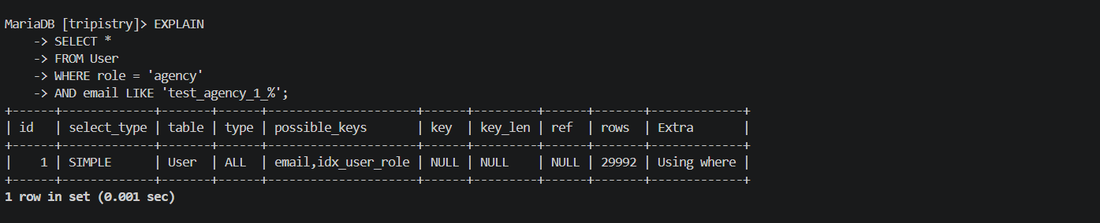

First Optimisation Attempt
An index was added on the role column:
CREATE INDEX idx_user_role
ON User(role);
Observation
Although MariaDB recognised the index as a possible key, it still chose a full table scan because the role column had low selectivity. Most rows contained the value 'agency', making the index inefficient for filtering.

Improved Query
SELECT *
FROM User
WHERE role = 'agency'
AND email LIKE 'test_agency_1_%';

Final Optimisation
A composite index was created:
CREATE INDEX idx_user_role_email
ON User(role, email);

Execution Plan After Final Optimisation
After Optimisation
- Access Type: ref
- Key Used: idx_user_role_email
- Extra: Using index condition
Rows Examined: 15407
Explanation
The composite index improved query selectivity by indexing both the role and email columns together. MariaDB was able to use indexed lookups instead of performing a full table scan, resulting in a more efficient execution plan.
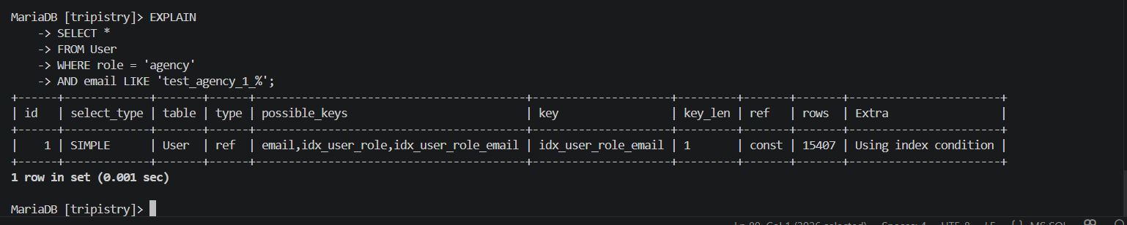
Conclusion
The optimisation process demonstrated how indexing strategy and column selectivity affect query performance. A single-column index on a low-selectivity column did not improve performance, while a composite index allowed MariaDB to use indexed filtering effectively.

